3.3.1 Installation Process
System needs to have python 3.11+ on https://www.python.org/downloads/, Git terminal on https://git-scm.com/install/ and winrar on https://www.win-rar.com/start.html?&L=0 installed.

Step 1: Extract the “phishshield’ folder using winrar
Expectation: The extracted folder should contain: .venv, PD_URL and bash.exe

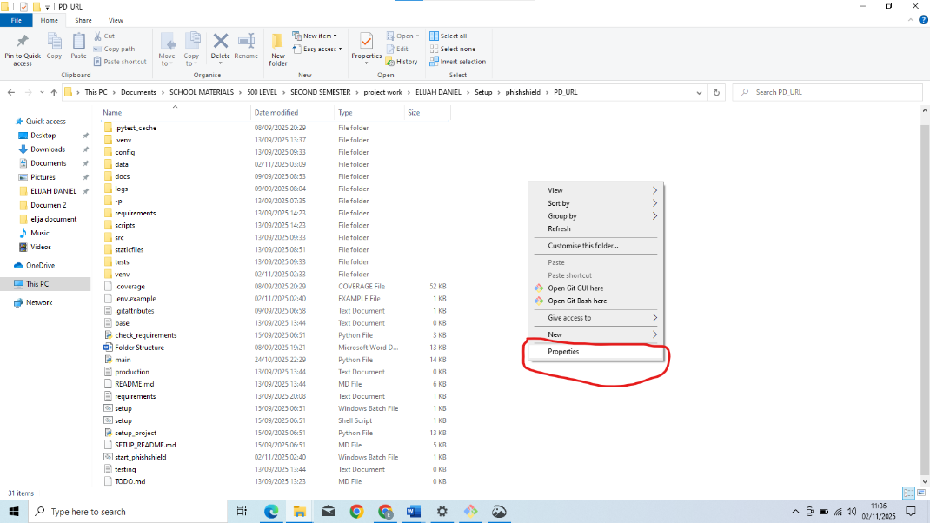
Step 2a: Open the extracted the “phishshield’ folder, then Open the “PD_URL” folder, right click on the folder environment and click on the properties from the pup-up to know the location of the folder

Expectation: The PD_URL folder should contain 31 items both folder and file, the property should show the location of the PD_URL folder
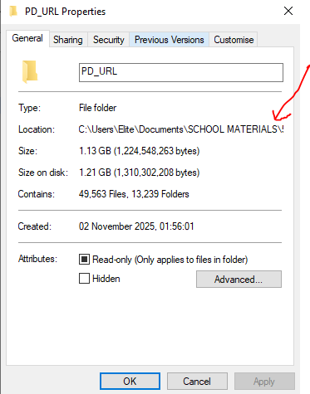

Step 2b: Right click on “PD_URL” folder environment and open with Git Bash or cmd terminal
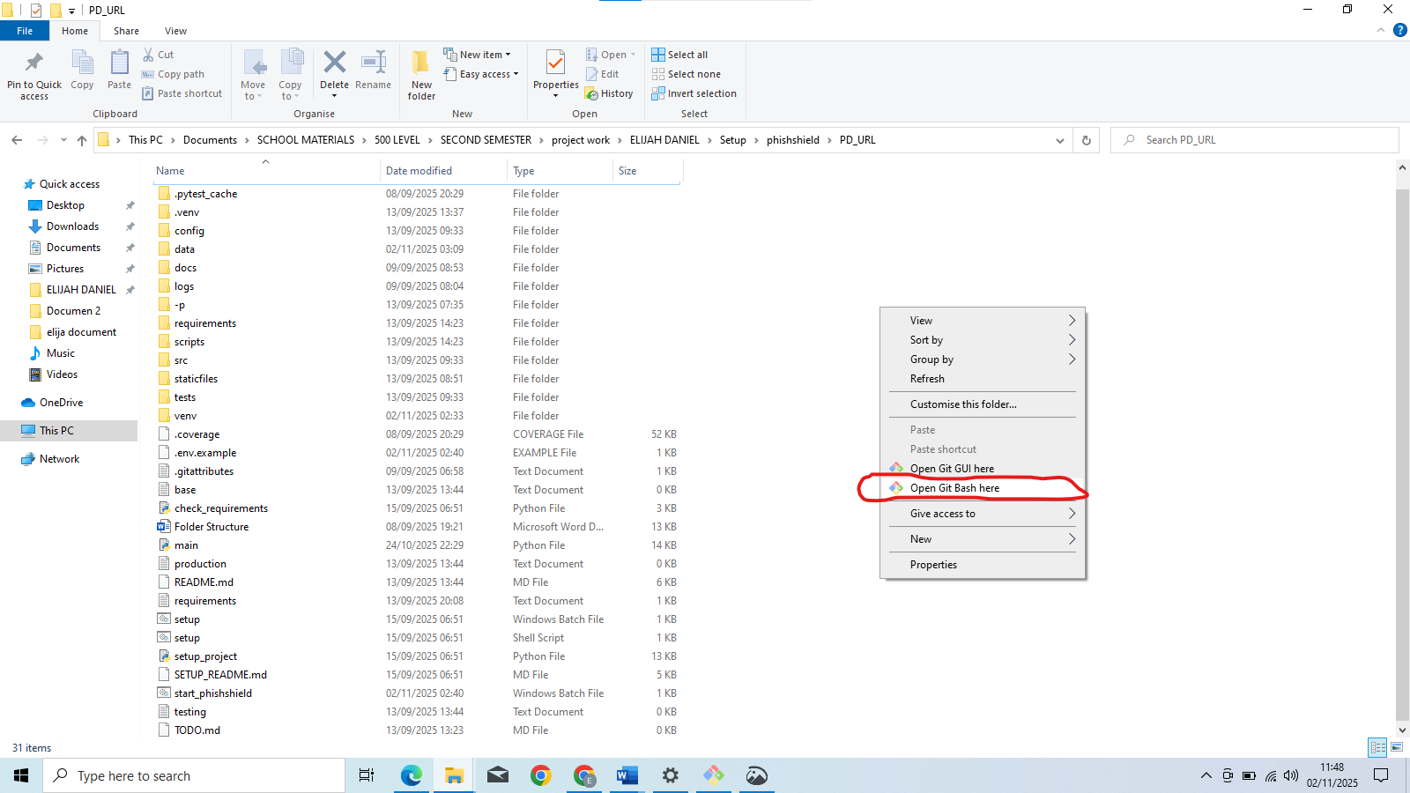

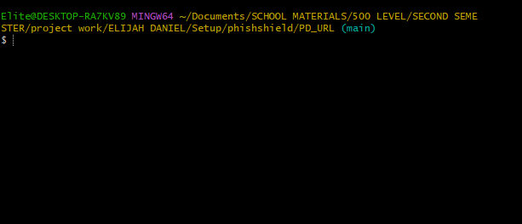
Expectation: Git Bash or cmd terminal should open with the location of the PD_URL folder

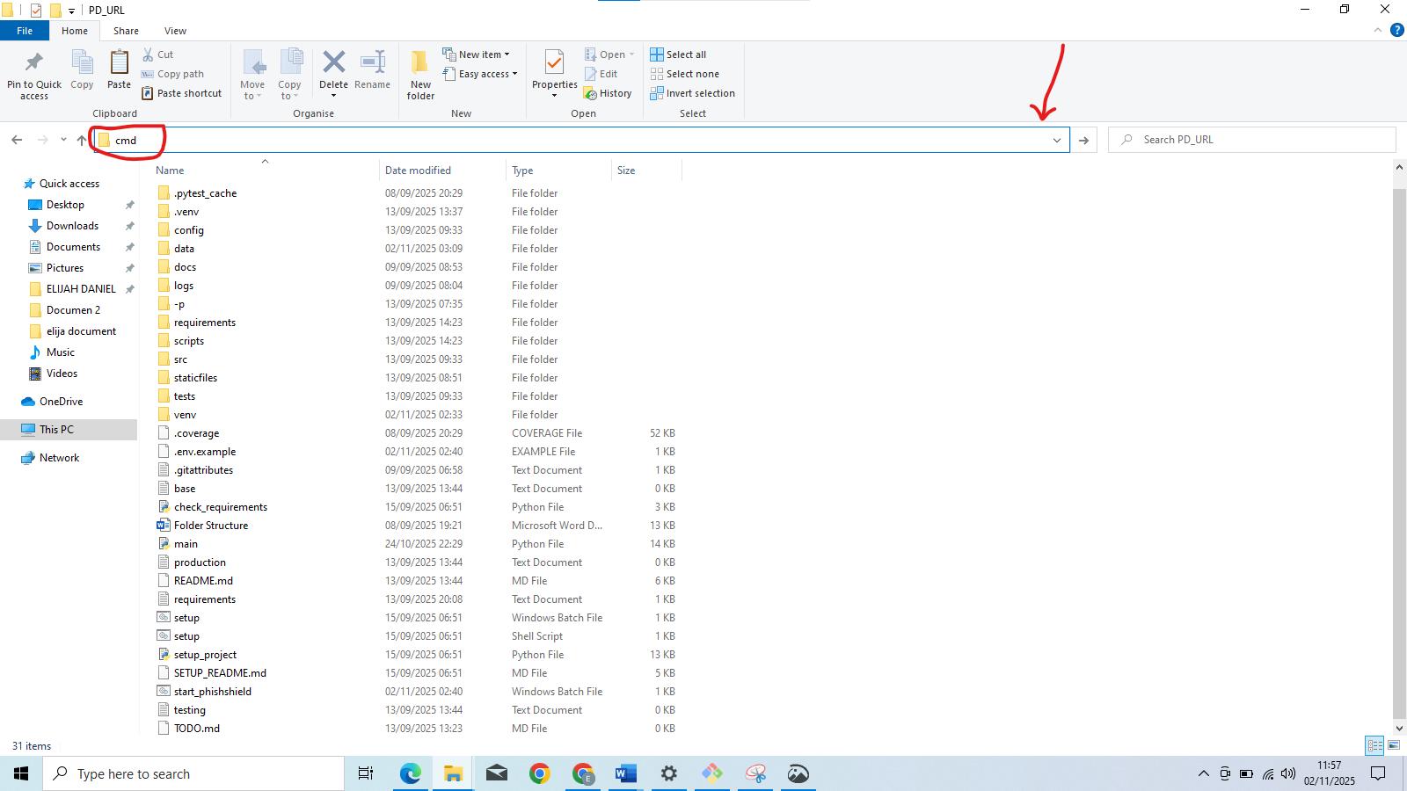
Step 2c: Open the “PD_URL” folder and type “cmd” on the search bar

Expectation: cmd terminal should open with the location of the PD_URL folder
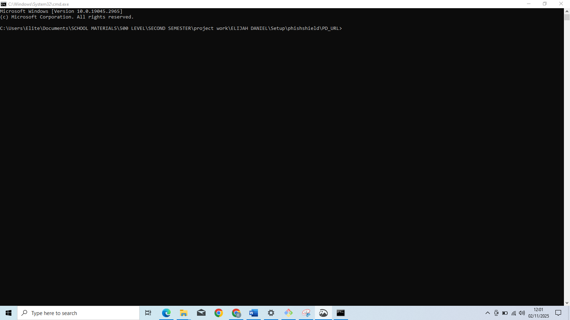
Step 3a: Run the setup script to create the virtual environment and install base requirements
Command Prompt: python setup_project.py
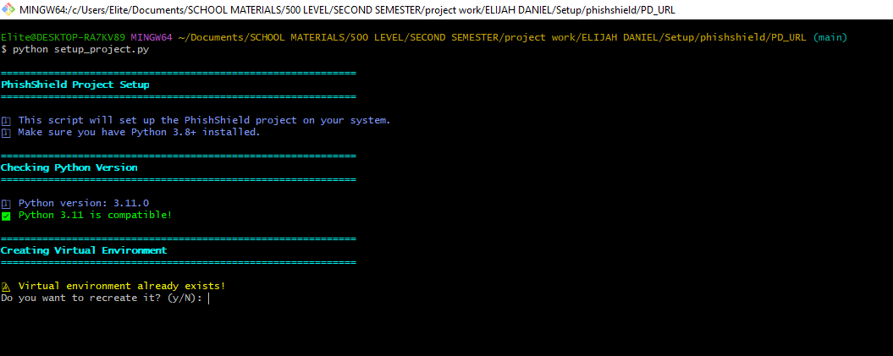
Expectation: This should create a visual environment needed for the project

Step 3b: This step will show “Virtual environment already exists; Do you want to recreate it?” (Y/N):

Expectation: Type “Y” and press enter key to create new virtual environment
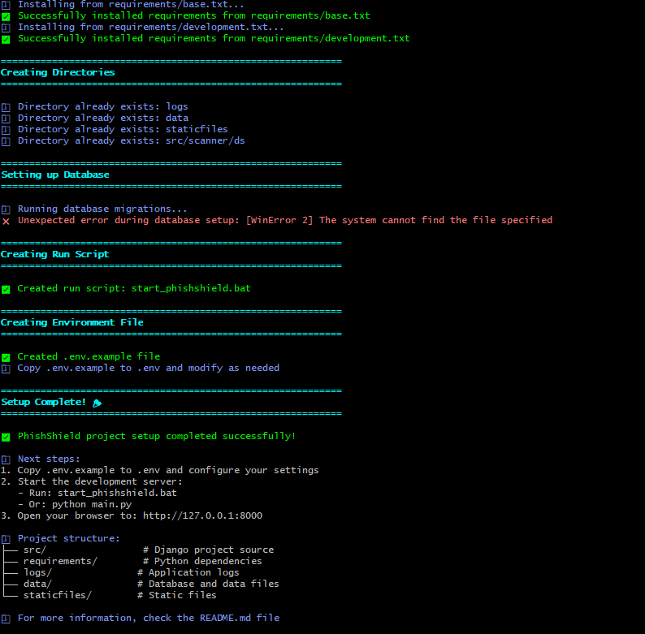

Step 4: Run the project
Command Prompt: python main.py
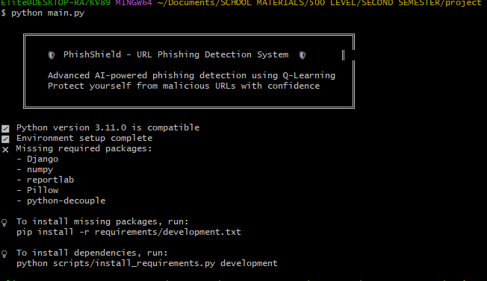

Expectation: This should show all the necessary components tick and run the project
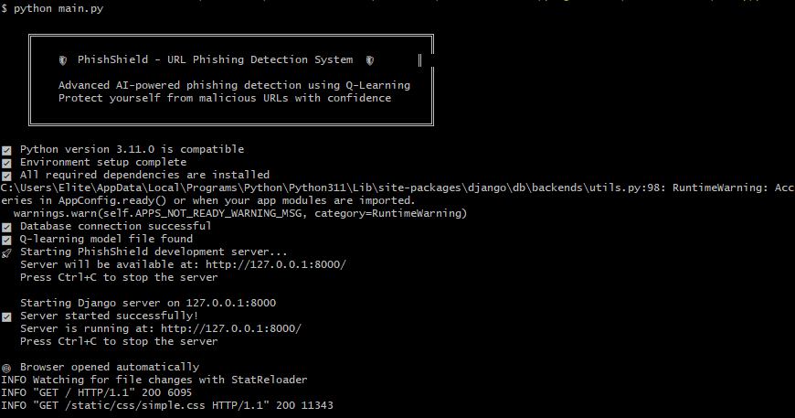
Step 5a: If packages are still missing (error during python main.py)
If the program complains about missing modules,
Step 5b: Install all development requirements needed in the virtual environment activated with: Command Prompt: pip install -r requirements/development.txt

Expectation: This should show the components that need to be install and suggest next thing to do
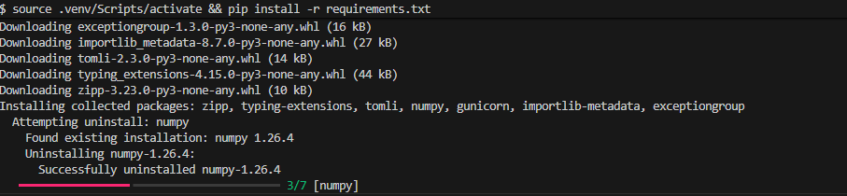

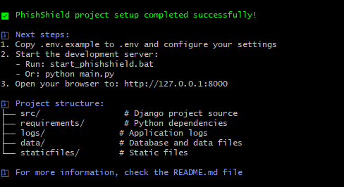
And

Step 6: Run the project again after successful installation
Command Prompt: python main.py

Expectation: This should show all the necessary components tick and run the project

Step 7: Open any browser and enter http://127.0.0.1:8000/ to open the Project
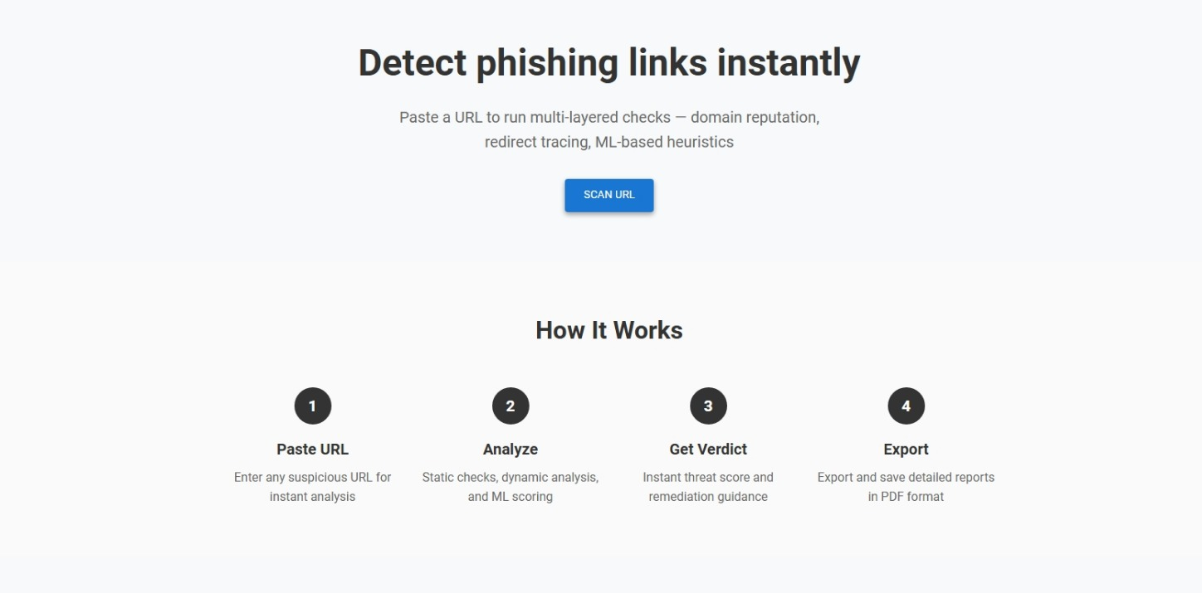

Test Login
Demo credential (use for testing)
- Admin login Username: admin / Password: admin
- User login: Username: John / Password: John
New user can also signup for more testing

Test URLs
Legitimate URLs:
- https://futminna.edu.ng/
- https://www.ubagroup.com/
- https://www.cbn.gov.ng/
Phishing URLs:
- www.dghjdgf.com/paypal.co.uk/cycgi-bin/webscrcmd=_home-customer&nav=1/loading.php
- myxxxcollection.com/v1/js/jih321/bpd.com.do/do/l.popular.php
- serviciosbys.com/paypal.cgi.bin.get-into.herf.secure.dispatch35463256rzr321654641dsf654321874/href/href/href/secure/center/update/limit/seccure/4d7a1ff5c55825a2e632a679c2fd5353/
You also get both legitimate and phishing URLs from the link below for more testing: https://www.kaggle.com/datasets/taruntiwarihp/phishing-site-urls

